

**Edwinstree Middle School**

**A Voluntary Controlled Church of England School**

**Norfolk Road Buntingford, Hertfordshire, SG9 9AW**

**Our faith supports each individual to flourish and challenges us to live life in all its fullness**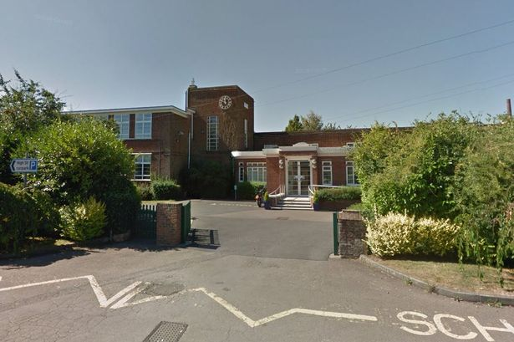

As a Christian school we recognise the unique and wonderful in everyone.

As a community, we support one another to flourish, and live life in all its fullness.

As a middle school, we are able to combine the care and nurture of primary specialists and their deep understanding of the building blocks of Mathematics and English, with a team of subject specialists from secondary school backgrounds. This provides us with a unique opportunity to inspire all students with our science, design and technology, music, computing, PE and art specialist facilities.

**We place a strong emphasis on staff development and we support progression into leadership roles.**

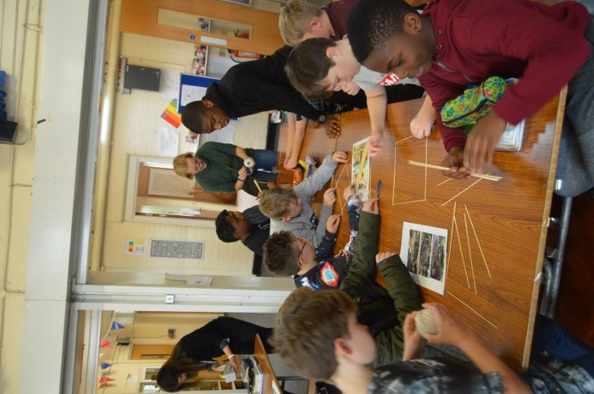We are determined that by the time Edwinstree students leave us, they will be confident and proficient in the core curriculum, independent learners, curious and passionate about the world around them and compassionate with each other and themselves.

Edwinstree Middle School is committed to safeguarding and promoting the safety and welfare of all our children and expects staff to share this commitment. Appointment to this post is subject to satisfactory clearance of enhanced Disclosure and Barring Service (DBS) checks, including the barred list, as well as all other pre-appointment checks in accordance with Keeping Children Safe in Education (2023)

Mrs Gant, leading ‘Fullness Day’

**Frequently Asked Questions**

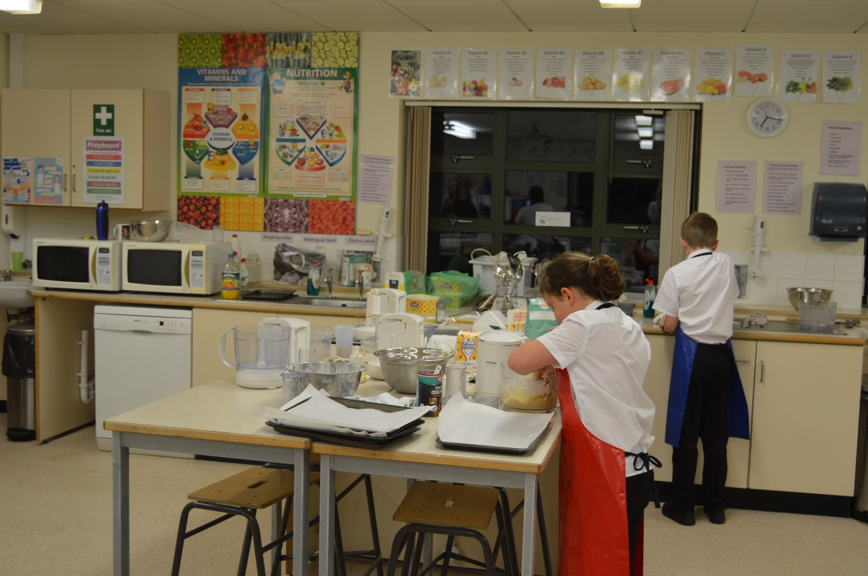

**How big is Edwinstree?**

We are four-form entry. As Buntingford continues to grow – so will we.

**Will I be a form tutor?**

Most teachers are responsible for a form.

**What is a Middle School?**

In this area of Hertfordshire

-The Rib Valley- we follow a three-tier education system.

First Schools: Years R-4

Middle Schools: Years 5-8

Upper Schools (High Schools): Years 9-11 and 6th Form

As this is an unusual age-range our adverts attract as wide an audience as possible - as we try to find our ideal new staff member.

**Do I have to be a Christian to teach at Edwinstree?**

We encourage everyone to join us: people of any faith or none. We explore Christian Values to help us live life in all its fullness.

**Which subjects will I teach?**

Most staff will teach a specialist subject and one or two others. We will discuss our mutual needs at interview.

**What is a school day like?**

At Edwinstree students are taught in mixed ability tutor groups for all subjects. Students move around the school throughout the day. We have four one-hour lessons before lunch (with a morning break) and a one hour lesson after lunch plus Collective Worship. Various extra-curricular activities run during lunchtime and after school. We find this structure supports morning learning for our young adolescents.

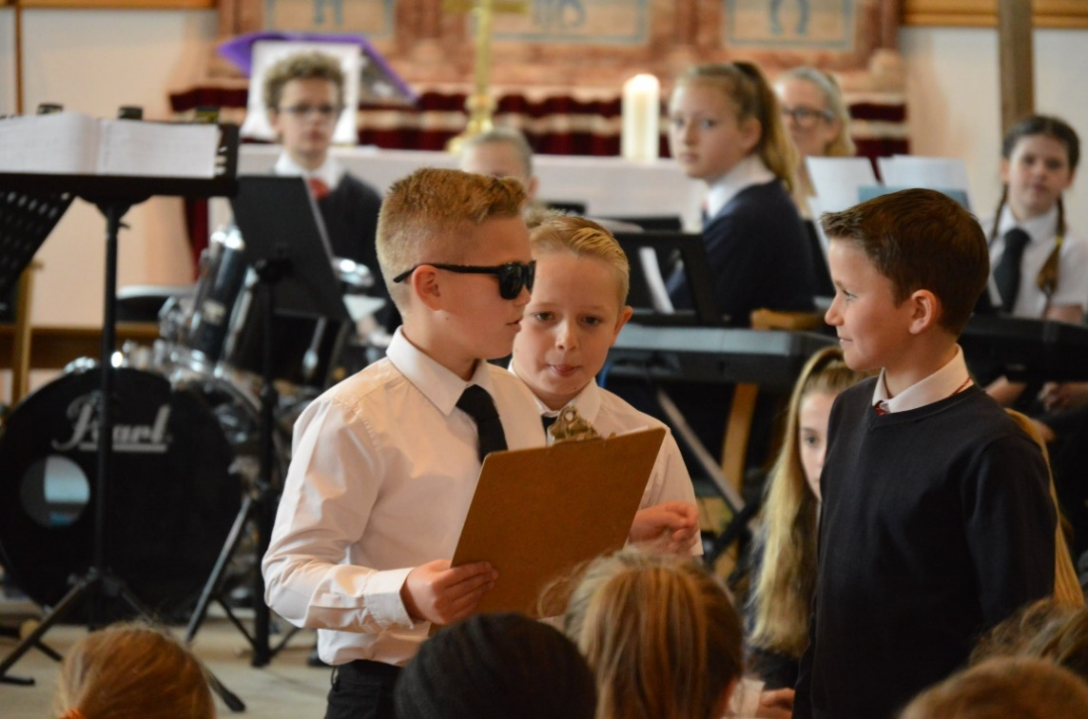

| **ROLE PROFILE** | | | |
| --- | --- | --- | --- |
| **YOUR ROLE IN CONTEXT: OUR SCHOOL** | **YOUR ROLE IN ACTION: TEACHING, LEARNING AND LEADING EXPECTATIONS** | **YOUR NEED TO KNOW: YOUR SKILLS AND KNOWLEDGE** | **YOUR NEED TO BE: YOUR EXPERIENCE AND PERSONALITY** |
| **Our faith supports each individual to flourish and challenges us to live life in all its fullness.**  **Edwinstree staff demonstrate commitment to a shared vision of the school where students are:**   * able to describe the Christian Values they hold dear and how they help them to live well together * curious and critical * excited about their learning * fluent in literacy and numeracy skills in order to flourish * able to describe an experience of spirituality: living life in all its fullness * beginning to describe their personal ‘wonderful’ * confident learners within a variety of subject areas * independent learners: they believe that they can achieve * able to demonstrate endurance * able to celebrate difference * compassionate with each other and themselves * able to keep themselves healthy - in body and mind * passionate about the world around them and care for the environment | **Class Teachers**   * Ensure best practice in providing a happy, safe and secure learning environment * Have responsibility for a tutor group and the related administrative duties, liaising with Heads of Year on matters of pastoral care * Take responsibility for behaviour: follow the school’s behaviour policy, centred around Restorative Justice * Liaise effectively with parents, governors and external agencies * Work closely with the appropriate subject leaders * Follow the curriculum intent using the planned scheme of work * Identify possible misconceptions and deliver creative approaches to bridge gaps in learning * Assess and record students attainment and progress * Take a full and active part supporting school improvement * Take on any additional responsibilities determined by the Headteacher   **Subject Leaders**   * Coach and support the rest of the faculty with guidance from the line manager * Inspire high performance * Quality assure and moderate data * Successfully establish a curriculum of excellence following school guidelines * Understand how a subject grows from a student’s first encounters to rich understanding, knowledge and skills * Promote subject learning across the wider curriculum and the whole school * Understand how maths and literacy learning naturally fits into a subject * Contribute to wider strategic planning | **Be the Expert**   * Qualified Teacher Status * Fulfil the requirements of the Teaching Standards * Communicate clearly (both written and oral) * Be a passionate artisan - who can deliver high quality, engaging lessons, which cultivate curiosity * Be up to date with cutting edge ideas/models of excellence and able to adapt them to suit Edwinstree * Use adapted learning to meet the needs of the individual * Use effective questioning techniques * Deliver impactful feedback - which contributes to student progress * Analyse and make use of assessment data * Systematically keep records * Plan strategically | **Be the person**   * Be sympathetic to our Christian Values * Value inclusivity * Conduct is honest and shows integrity * Maintain confidentiality * Be reflective * Remain focused on priorities * Continually seek ways to improve and learn * Apply alternative thinking to problems to generate creative solutions * Listen actively * Adapt style appropriately to suit the audience * Build positive relationships * Take an interest in student voice * Ability to work alone * Enjoy working as part of a team * Work flexibly when required |



“Our school is unique: we support everyone and accept the way they are.” (Edwinstree Student)

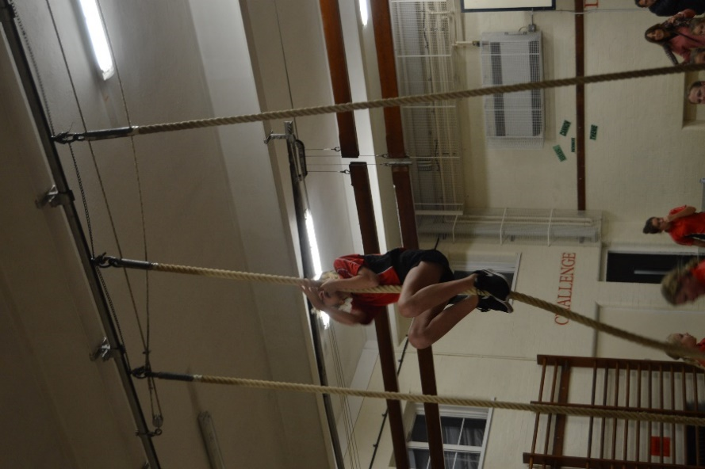

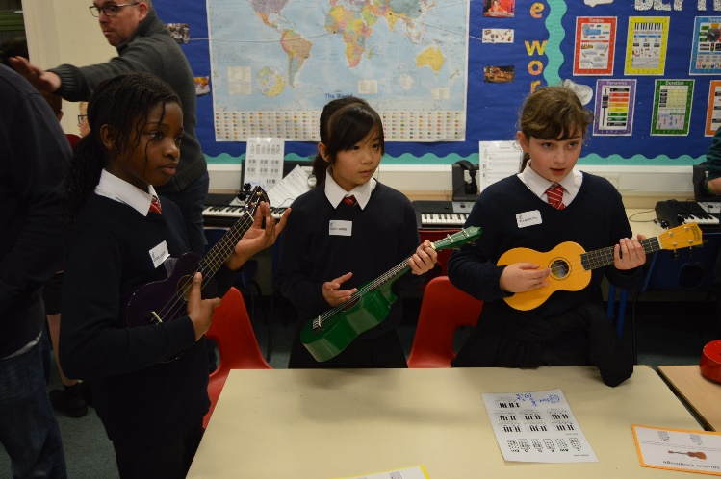

“The Edwinstree staff are supportive, encouraging and exciting to work with.”

(Class Teacher)

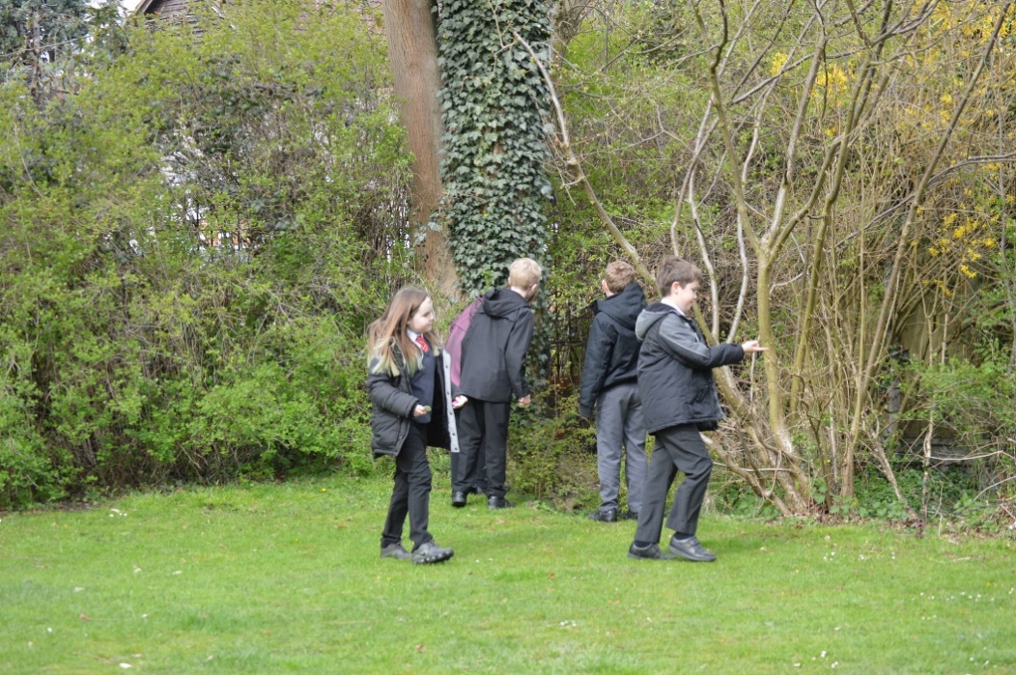

Edwinstree has an extremely strong Leadership Team guiding me through a challenging year. Edwinstree has made it easy for me to settle in and I couldn’t have asked for more. (ECT)

It is lovely to be part of a team who are encouraged to put forward new ideas. (Learning Support Assistant)



“We have an excellent body of staff and it would become even better with you teaching and guiding us!” (Edwinstree Student)

**Don’t take our word for it: come and see the ‘Magic of Edwinstree’ for yourself**

**Please contact Mrs Sam Petty (PA to Headteacher: Mrs J Gant) for more information**

**01763-271446 or s.petty@edwinstree.herts.sch.uk**