- Go to: Music Lessons (hertsmusicservice.org.uk)

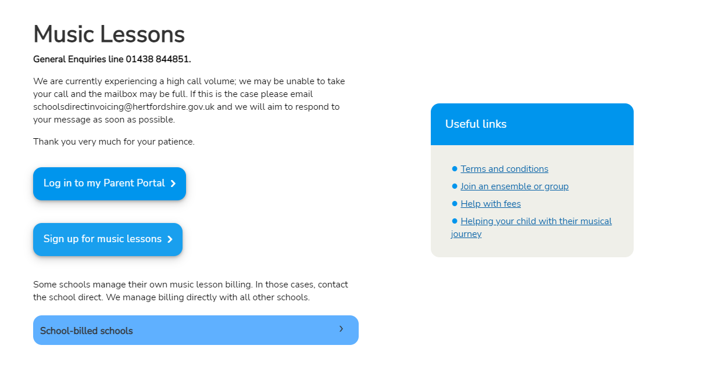
- Click ‘Sign up for music lessons’

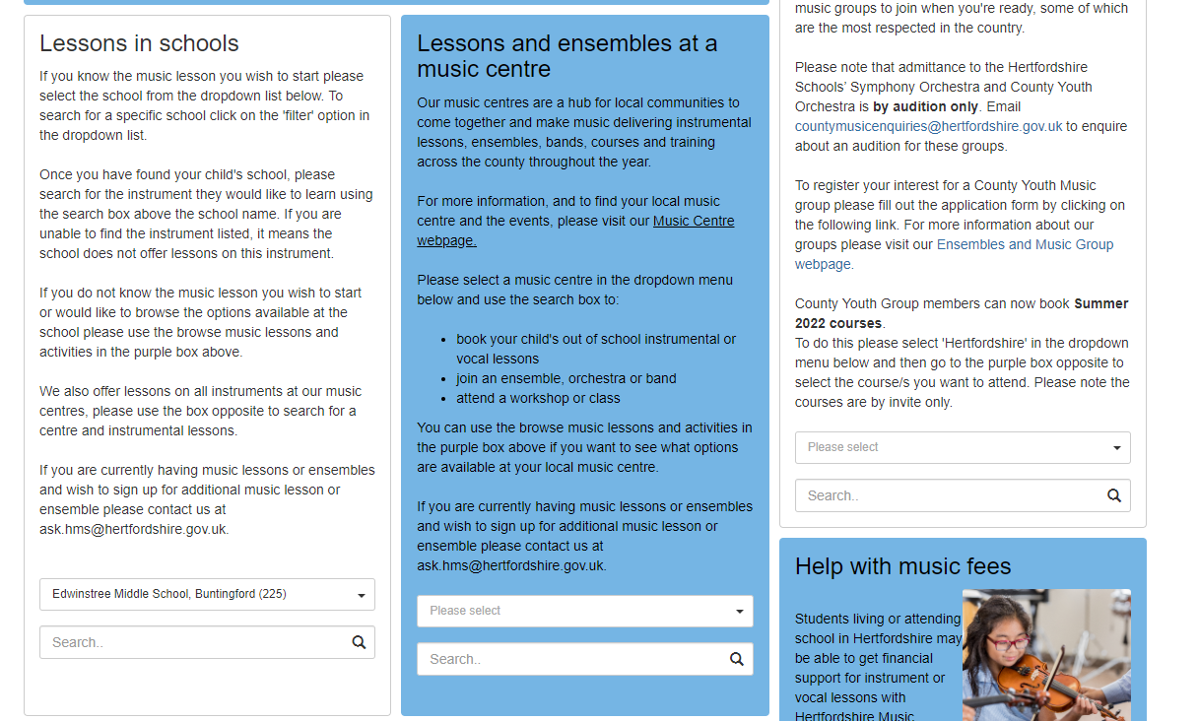
- Scroll down and find the ‘Lessons in schools’ section.

- Find Edwinstree Middle School in the drop-down menu and then search the instrument your son/daughter is interested in.

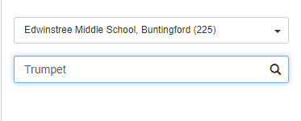

- Select the type of lesson you would like for your son/daughter and then add a comment about their level or musical ability (e.g. ‘Beginner’; ‘Hasn’t played saxophone, but plays piano and reads music’; ‘Grade 2 completed’)
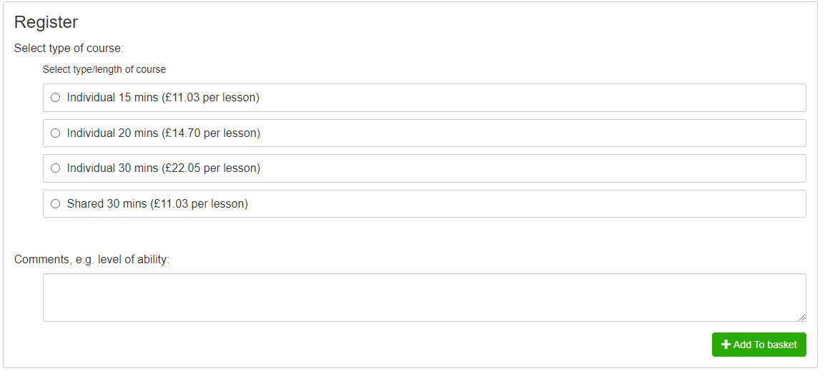

- If you receive certain benefits and/or free school meals, you may be entitled to 50% or 100% funding for music lessons through Hertfordshire Music Service. Click this link to find out more information and apply.
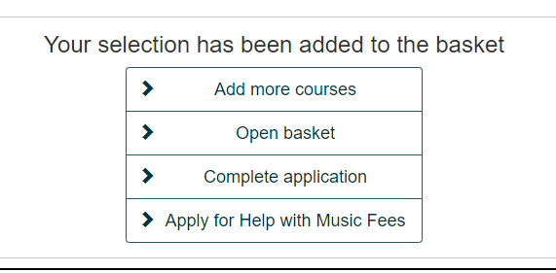

- Once you have completed this step, or if you do not need this step. You then need to complete the application form to finish.

- Once you have done this, you should be able to proceed to payment. You will then be contacted by Hertfordshire Music Service regarding the lessons. A peripatetic teacher will be assigned and will also contact you with your son/daughter’s lesson day/time.

