**LATEST UPDATE FROM COUNTY – 19/1/2022**

**Isolation periods for people who test positive for COVID-19 have changed**

From Monday 17 January, people who are self-isolating with COVID-19 have the option to reduce their isolation period after 5 full days if they test negative with an LFD test on both day 5 and day 6 and do not have a temperature. The day when you developed symptoms or tested positive is counted as day zero.

For example, if they test negative on the morning of day 5 and the morning of day 6, they can return to their education or childcare setting immediately on day 6.

The first test must be taken no earlier than day 5 of the self-isolation period, and the second must be taken the following day. All test results should be reported at:

<https://www.gov.uk/report-covid19-result?utm_source=18%20January%202022%20C19&utm_medium=Daily%20Email%20C19&utm_campaign=DfE%20C19>

If the result of either test is positive, they should continue to self-isolate until they get negative results from two LFD tests on consecutive days or until they have completed 10 full days of self-isolation, whichever is earliest. The new rules also apply to people who are already isolating – so if someone was already isolating before Monday 17 January, they can take LFD tests on day 5 and 6 and if they are both negative and they have no temperature they can end their isolation.

You may find this table useful:

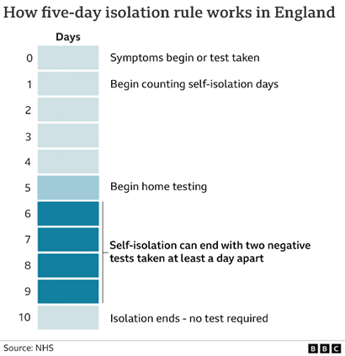

For example:

* Child A tested positive on 14 January, which is day zero. They could take an LFD test today, 19 January at 8am and another on 20 January at 8am and proving both tests are negative, the child can return to school on 20 January.
* Child B tested positive on 14 January, they do an LFD test on 19 January and it is positive. They will need to test on 20 January and 21 January which will both have to be negative before they can end self-isolation and return to the setting.
* If a child or member of staff continue testing positive up until day 10, they can end self-isolation on day 11, with day zero being the day they originally developed symptoms or tested positive.

Anyone unable to take LFD tests or who continues to have a temperature will need to complete the full 10-day self-isolation period.

This change applies to all positive cases, regardless of vaccination status.

Further information on self-isolation for those with COVID-19 is available at: <https://www.gov.uk/government/publications/covid-19-stay-at-home-guidance/stay-at-home-guidance-for-households-with-possible-coronavirus-covid-19-infection>

Reminder that FAQs and other documents may have changed, please keep an eye on the Grid and check regularly for updated information: <https://thegrid.org.uk/covid-19/key-documents-for-schools>