Outdoor Learning Area
Over the course of this academic year, we will be raising funds with plans to install an outdoor learning area for the benefit of all our school community. Outdoor learning has proven to be beneficial for a number of reasons, especially improving wellbeing, mental health and concentration. We plan to use the space to enrich the learning experience in all areas of the curriculum with learning opportunities such as outdoor painting during Art lessons, or nature observations in Science.
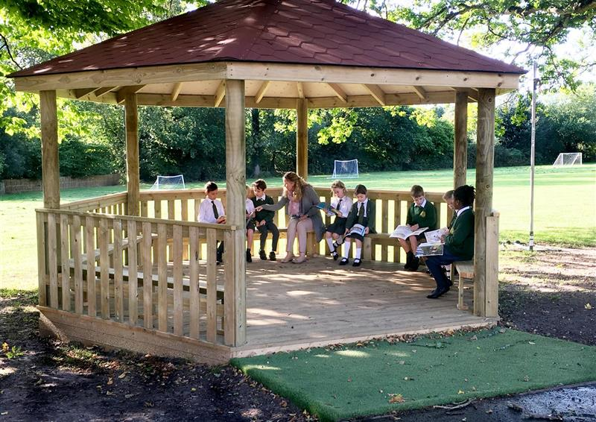
We need your help!
We are very excited that Edwinstree has been chosen by the Co-op as one of the local causes that will be part of the Co-op Community Fund from Sunday 24th October for one year. By choosing Edwinstree as your local cause every time you use your membership card in store when you make a purchase, a small contribution will go into the fund. It will not cost you anything and you will also receive 2p for every £1 spent on your membership card. Please tell your friends and family and together we could raise enough funds to provide this wonderful learning opportunity.
You can get a membership card in store or by following this link: Co-op Membership - Membership that makes a difference - Co-op (coop.co.uk)
If you already have a card please follow this link to choose Edwinstree as your local cause (from Sunday 24th October) : Co-op - Local causes - Co-op (coop.co.uk)
If you need any assistance to get a membership card or to choose your local cause please email Mrs Heywood r.heywood@edwinstree.herts.sch.uk who will be happy to help.

Thank you in advance for your support

