Previous learning- Y7 Summer- The Problem of Evil

TOPIC- Ethics- how do we decide right from wrong?
Threshold- Define utilitarianism and apply it to a scenario.
Threshold- Define virtue ethics and apply it to a scenario.
Threshold- Define Kantian ethics and apply it to a scenario.
Threshold- Explain how several religions decide right from wrong
Future Learning- Discrimination- Islamophobia and the Holocaust

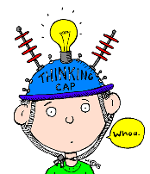
I deepened my thinking this term when I…

Previous learning- Ethics- how do we decide right from wrong?
TOPIC- Discrimination-Islamophobia and the Holocaust
Threshold- Define both the Holocaust and Islamophobia
Threshold- Consider why it is important that we study these topics
Threshold- Think of ways we can help support equality and combat discrimination
Future Learning- The Death Penalty- To kill or not to kill?

I deepened my thinking this term when I…

Previous learning- Discrimination-Islamophobia and the Holocaust
TOPIC- The Death Penalty- to kill or not to kill?
Threshold- Define the death penalty
Threshold- Identify arguments both for and against the death penalty
Threshold- Outline some religious responses to the death penalty
Threshold- Express their own view giving two reasons
Future Learning- Upper School Y9 and GCSE

I deepened my thinking this term when I…

